**DEPARTMENT OF**

**ELECTRONICS AND COMMUNICATION ENGINEERING**

**College of Engineering and Technology**

**SRM Institute of Science and Technology**

MINI PROJECT REPORT

ODD Semester, 2023-24

Lab code & Name : 21ECC203T – DIGITAL LOGIC DESIGN

Year & Semester : II Year, IV semester

Project Title : 4x4 MULTIPLIER

Course Teacher **:** Dr. E. SIVAKUMAR

Assistant professor

Electronics and Communication Department

Team Members : Charukesh S, Anbuchezhian T, Arunprasath M, Vijayan V

|  |  |  |  |
| --- | --- | --- | --- |
| Reg. No | RA1911004010002 | RA1911004010008 | RA1911004010009 |
| Mark split up | RA2211004010572 |
| Novelty in the project work  (10 marks) |  |  |  |  |
| Level of understanding of the design formula (5 marks) |  |  |  |  |
| Contribution to the project  (5 Marks) |  |  |  |  |
| Report writing (10 Marks) |  |  |  |  |
| **Total (30 Marks)** |  |  |  |  |

Date: **Signature of Course Teacher**

**4X4 MULTIPLIER**

**OBJECTIVE:**

The primary objective for the 4x4 multiplier design is to create a digital circuit that efficiently and precisely multiplies two 4-bit binary numbers, yielding an 8-bit product.

**ABSTRACT:**

This project endeavors to create a high-performing 4x4 multiplier, a key element in digital systems for arithmetic tasks. Its core objective is to efficiently and precisely multiply 4-bit binary numbers, yielding an 8-bit result. This multiplier serves vital functions in digital signal processing and mathematics. The design emphasizes accuracy, efficiency, speed, and compactness, ensuring compatibility and scalability while maintaining low power consumption.

**INTRODUCTION:**

Multiplication, a fundamental operation in mathematics, is essential in digital and computational systems. A 4x4 multiplication specifically entails the precise multiplication of two 4-bit binary numbers, resulting in an 8-bit outcome. This operation is widely applied in digital signal processing, microprocessor architecture, and many binary arithmetic scenarios.

A 4x4 multiplier refers to the digital circuit or algorithm designed for efficient and accurate execution of this multiplication. Its significance lies in its ability to swiftly compute products while maintaining precision in diverse digital applications.

The process involves multiplying each bit of one 4-bit number with each bit of the other, creating partial products that are then summed to produce the final 8-bit product. A well-designed 4x4 multiplier should consider factors like speed, accuracy, power efficiency, and compatibility within the broader digital system.

**HARDWARE REQUIREMENT/DESCRIPTION:**

Bread Boards, Battery ( 9 VOLT ), IC 74LS08(Quad 2-input AND gate),

IC 74LS86(Quad 2-input XOR gate), 74LS32(Quad 2-input OR gate),DIP Switch**,**

Red LED,Resistance (220 Ω), 5 Volt Regulator.

**CIRCUIT/COMPONENT SPECIFICATIONS:**

|  |  |
| --- | --- |
| Supply voltage (*V*CC) | 5V |
| Supply current (*V*CC = +5 V) | 3 to 6 mA |
| Output current (maximum) | 200 mA |
| Power consumption (minimum operating) | 30 mW@5V |
| [Operating temperature](http://en.wikipedia.org/wiki/Operating_temperature) | 0 to 70 °C |

**CIRCUIT DIAGRAM:**

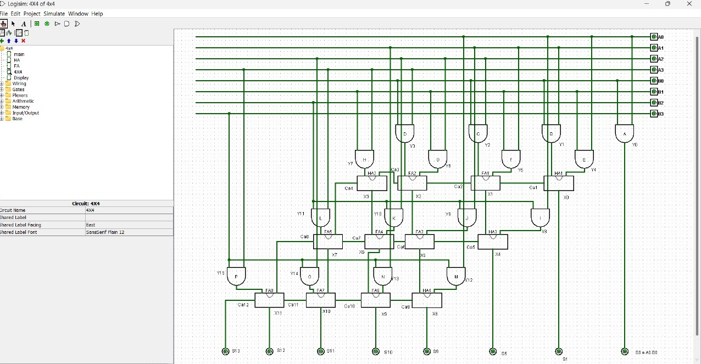

**DESIGN FORMULA:**

1 0 1 1 (This is the first 4-bit binary number)

x 0 1 0 0 (This is the second 4-bit binary number)

------------

0 0 0 0 (0x1)

1 0 1 1 0 (1x10)

0 0 0 0 0 (0x100)

+ 1 0 1 1 0 (1x1000)

---------------

1 0 0 0 1 0 0 (This is the 8-bit binary result)

**DESIGN ISSUES:**

* Maximum supply voltage should not exceed 15V
* Humidity should not exceed 85% relative humidity.
* Timing tolerance should not exceed +10 sec for 1 min.

**APPROACH/METHODOLOGY:**

Combinational logic is a straightforward approach for designing a 4x4 multiplier. In this method, you directly compute each of the 8 product bits (P7 to P0) by performing a set of logical operations on the input bits. Here's how it works:

Bitwise Multiplication: For each bit of the first 4-bit number (A) and each bit of the second 4-bit number (B), perform a bitwise multiplication (AND operation). This results in 16 partial products, which are essentially the individual bits of the final product.

Partial Product Formation: The partial products are organized and aligned in a grid, where each partial product corresponds to a specific bit position in the final product.

Addition: Sum all these partial products together to obtain the final 8-bit product. This summation can be done using full adders, which consider the carry from the previous bit.

**RESULTS:**

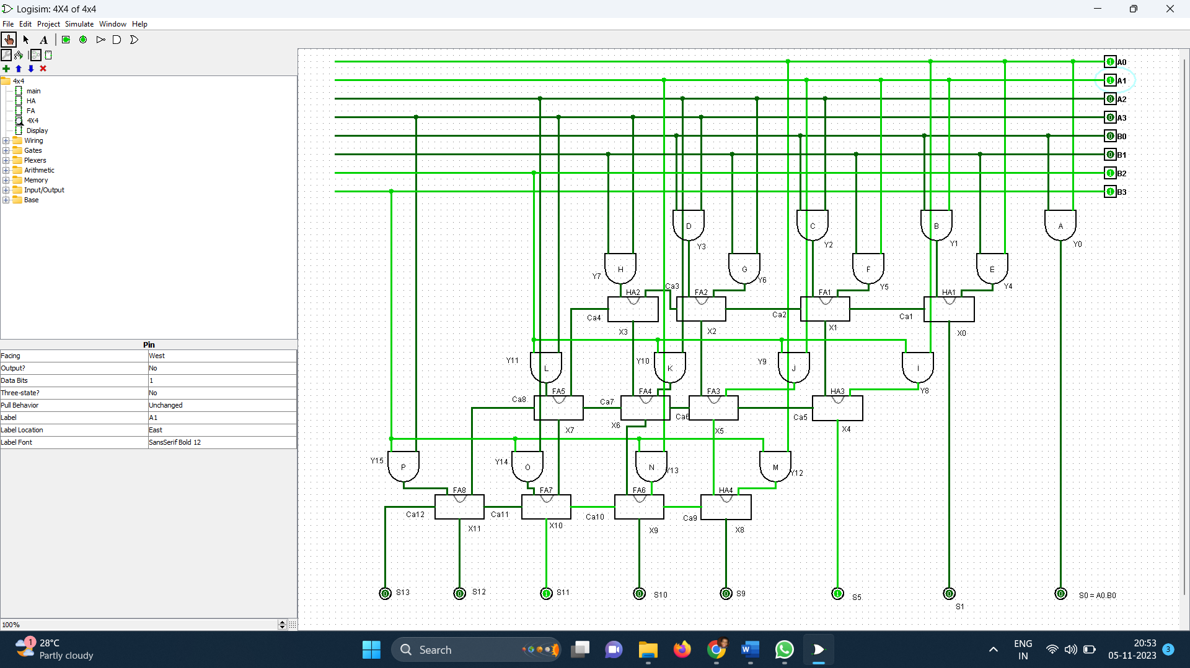

**CONCLUSIONS:**

To conclude, the 4x4 multiplier is a vital element in digital systems, enabling efficient 4-bit binary multiplication to produce an 8-bit product. Its broad application in digital signal processing, microprocessors, and more underscores its importance.

**REFERENCES:**

https://www.youtube.com/watch?v=q0SzMHSyVy0&pp=ygUWNCo0IGNpcmN1aXQgbXVsdGlwbGllcg%3D%3D

**APPENDIX:**

**BREAD BOARDS**

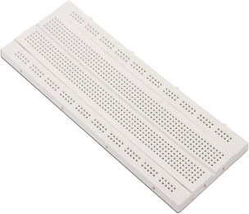

A breadboard is a fundamental tool used in electronics and prototyping to create temporary electrical connections between electronic components, allowing for quick and easy testing and experimentation without the need for soldering..

**BATTERY ( 9 VOLT ) :**

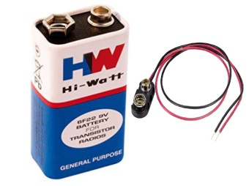

A 9-volt battery is a type of portable power source commonly used in various electronic devices.

**IC 74LS08(Quad 2-input AND gate**)**:**

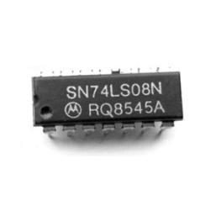

The IC 74LS08 is a popular integrated circuit (IC) that belongs to the 74LSxx series of TTL (Transistor-Transistor Logic) logic gates. Specifically, the 74LS08 is a quad 2-input AND gate IC. It contains four individual AND gates, each with two inputs and one output..

**IC 74LS86(Quad 2-input XOR gate):**

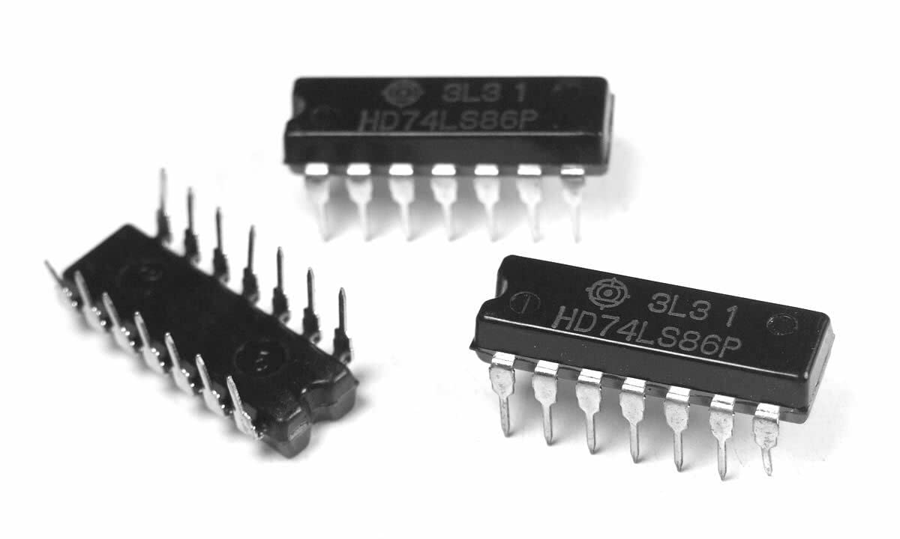

The IC 74LS86 is a commonly used integrated circuit (IC) that belongs to the 74LSxx series of TTL (Transistor-Transistor Logic) logic gates. It is a Quad 2-input XOR gate IC, which means it contains four individual XOR gates, each with two inputs and one output.

.

**74LS32(Quad 2-input OR gate**)**:**

* 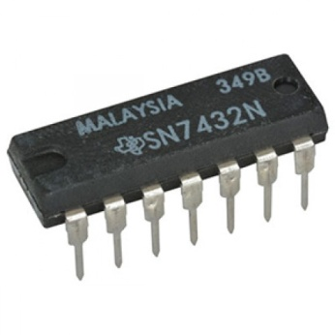

The IC 74LS32 is a commonly used integrated circuit (IC) that belongs to the 74LSxx series of TTL (Transistor-Transistor Logic) logic gates. It is a Quad 2-input OR gate IC, which means it contains four individual OR gates, each with two inputs and one output.

**DIP SWITCH :**

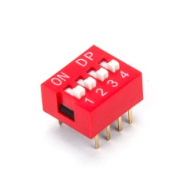

A DIP switch, short for "Dual In-line Package switch," is a manual electronic component used to configure or set certain parameters or options in a circuit or electronic device.

**RED LED:**



An LED, or Light Emitting Diode, is a semiconductor device that emits light when an electric current passes through it. LEDs are widely used for various applications due to their energy efficiency, long lifespan, and versatility.

**RESISTANCE (220 Ω) :**



Resistance, in the context of electronics and electrical engineering, refers to the opposition that an electrical component or material offers to the flow of electric current.

**5** **VOLT REGULATOR**

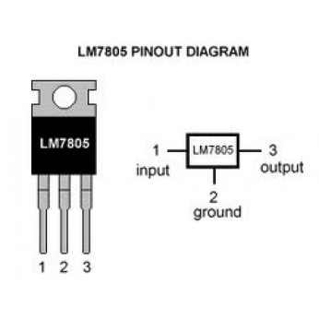

A 5-volt regulator is an electronic device or circuit that is used to maintain a stable and regulated 5-volt output voltage, regardless of variations in the input voltage or load conditions.